**Introduction to Html**

# What is Html?

### Def

* HTML stands for Hyper Text Markup Language
* HTML is the standard markup language for creating Web pages
* HTML is Not Case Sensitive
* HTML elements tell the browser how to display the content.
* Every HTML document/web page will have only one set of
* HTML document/web page is saved with .htm or .html extension.

### Main Tags

<html>...</html> tag

<head>...</head> tag

<body>...</body> tag

# Html Document Structure

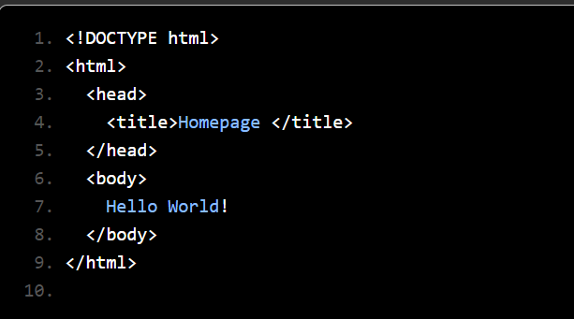

### The <!DOCTYPE> Declaration

* The <!DOCTYPE> declaration represents the document type, and helps browsers to display web pages correctly.
* It must only appear once, at the top of the page (before any HTML tags).

### Tags used with Head Tag

| **Tags** | **Description** |
| --- | --- |
| <title> | Defines the title that should be displayed on the browser tab |
| <meta> | Metadata is in-general, data about data.  Provides metadata about the HTML document.  Metadata will not be displayed on the page but will be machine-readable.  Used to specify page description, author of the document, last modified, etc.  Used by browsers (control how to display content or reload the page), search engines (keywords), or other web services.  Post HTML5, meta tag also allows web designers to take control over the viewport by setting the meta viewport tag. |
| <style> | Defines style information for the web page |
| <link> | Defines a link to other documents like CSS |
| <script> | Defines script like JavaScript |

# Html Elements

### Def

* The HTML element is everything from the start tag to the end tag:
* HTML elements can be nested (this means that elements can contain other elements)
* HTML elements with no content are called empty elements

### Syntax

<tagname>Content goes here...</tagname>

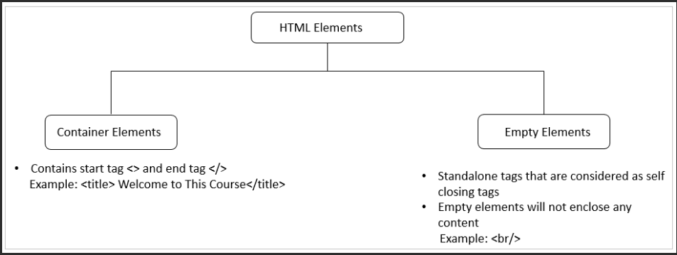

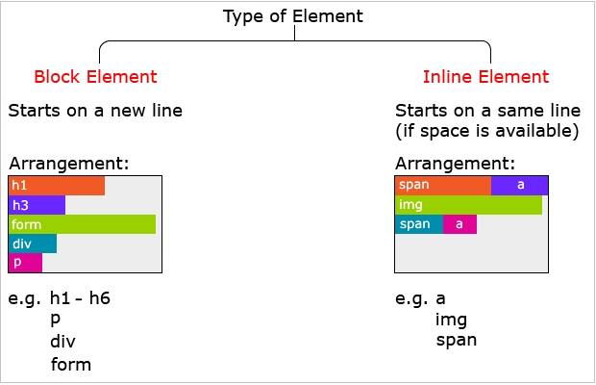

### Headings Element

HTML headings are defined with the <h1> to <h6> tags.

<h1> defines the most important heading.

<h6> defines the least important heading.

### Paragraphs Element

HTML paragraphs are defined with the <p> tag

### Links Element

HTML links are defined with the <a> tag

### Images Element

HTML images are defined with the <img> tag.

The source file (src), alternative text (alt), width, and height are provided as attributes

### Horizontal Rules

The <hr> tag defines a thematic break in an HTML page, and is most often displayed as a horizontal rule.

### Line Breaks

The HTML <br> element defines a line break.

### Character Entities

Character entities are used to include such character content on a web page.

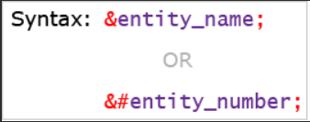

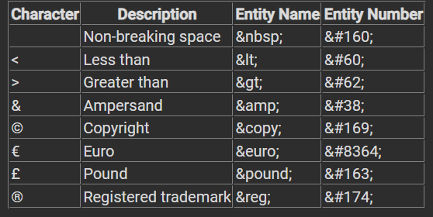

# Html Attributes

### Def

* All HTML elements can have attributes
* Attributes provide additional information about elements
* Attributes are always specified in the start tag
* Attributes usually come in name/value pairs like: name="value"

### Summary

* All HTML elements can have **attributes**
* The href attribute of <a> specifies the URL of the page the link goes to
* The src attribute of <img> specifies the path to the image to be displayed
* The width and height attributes of <img> provide size information for images
* The alt attribute of <img> provides an alternate text for an image
* The style attribute is used to add styles to an element, such as color, font, size, and more
* The lang attribute of the <html> tag declares the language of the Web page
* The title attribute defines some extra information about an element

### href Attribute

The <a> tag defines a hyperlink.

The href attribute specifies the URL of the page the link goes to:

<a href="https://www.w3schools.com">Visit W3Schools</a>

### src Attribute

The <img> tag is used to embed an image in an HTML page.

The src attribute specifies the path to the image to be displayed:

<img src="img_girl.jpg">

### width and height Attributes

The <img> tag should also contain the width and height attributes, which specify the width and height of the image (in pixels): <img src="img_girl.jpg" width="500" height="600">

### alt Attribute

<img src="img_girl.jpg" alt="Girl with a jacket">

### style Attribute

The style attribute is used to add styles to an element, such as color, font, size, and more.

<p style="color:red;">This is a red paragraph.</p>

### lang Attribute

<html lang="en">

### title Attribute - Tooltip

The title attribute defines some extra information about an element.

<p title="I'm a tooltip">This is a paragraph.</p>

## Global Attribute

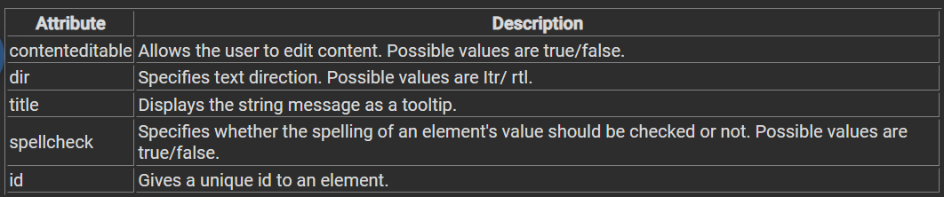

## Class Attribute

### Def

* The HTML class attribute specifies one or more class names for an element
* Classes are used by CSS and JavaScript to select and access specific elements
* The class name is case sensitive
* Different HTML elements can point to the same class name
* JavaScript can access elements with a specific class name with the getElementsByClassName() method

### Syntax rules

To create a class; write a period (.) character, followed by a class name. Then, define the CSS properties within curly braces {}.

### Multiple class

To define multiple classes, separate the class names with a space, e.g. <div class="city main">.

### Different Elements Can Share Same Class

<h2> and <p> point to the "city" class and will share the same style.

## Id Attribute

### Def

The HTML id attribute is used to specify a unique id for an HTML element.

You cannot have more than one element with the same id.

### Syntax rules

write a hash character (#), followed by an id name. Then, define the CSS properties within curly braces {}.

### Summary

* The id attribute is used to specify a unique id for an HTML element
* The value of the id attribute must be unique within the HTML document
* The id attribute is used by CSS and Javascript.
* The value of the id attribute is case sensitive
* The id attribute is also used to create HTML bookmarks
* JavaScript can access an element with a specific id with the getElementById() method

### Difference Between Class and ID

A class name can be used by multiple HTML elements, while an id name must only be used by one HTML element within the page.

### Bookmarks with ID and Links

First, create a bookmark with the id attribute:

<h2 id="C4">Chapter 4</h2>

Then, add a link to the bookmark, from within the same page:

<a href="#C4">Jump to Chapter 4</a>

## Style Attribute

### Def

Setting the style of an HTML element, can be done with the style attribute.

### Syntax

<tagname style="property:value;">

### Summary

* Use the style attribute for styling HTML elements
* Use background-color for background color
* Use color for text colors
* Use font-family for text fonts
* Use font-size for text sizes
* Use text-align for text alignment

### Background Color

The CSS background-color property defines the background color for an HTML element.

<body style="background-color:powderblue;">

### Text Color

The CSS color property defines the text color for an HTML element

<h1 style="color:blue;">This is a heading</h1>  
<p style="color:red;">This is a paragraph.</p>

### Fonts

The CSS font-family property defines the font to be used for an HTML element

<h1 style="font-family:verdana;">This is a heading</h1>

### Text Size

The CSS font-size property defines the text size for an HTML element

<h1 style="font-size:300%;">This is a heading</h1>

### Text Alignment

The CSS text-align property defines the horizontal text alignment for an HTML element

<h1 style="text-align:center;">Centered Heading</h1>

# HTML Formatting Elements

### Def

HTML Formatting is a process of formatting text for better look and feel. HTML provides us ability to format text without using CSS.

### Summary

Formatting elements were designed to display special types of text:

* <b> - Bold text
* <strong> - Important text
* <i> - Italic text
* <em> - Emphasized text
* <mark> - Marked text
* <small> - Smaller text
* <del> - Deleted text
* <ins> - Inserted text
* <sub> - Subscript text
* <sup> - Superscript text

### <b> and <strong> Elements

* The HTML <b> element defines bold text, without any extra importance.
* The HTML <strong> element defines text with strong importance

### <i> and <em> Elements

* The HTML <i> element defines a part of text in an alternate voice or mood
* The HTML <em> element defines emphasized text

### Quotation and Citation Elements

* <blockquote>, <q>,
* <abbr>, <address>,
* <cite>, and <bdo> HTML elements.

# Html Links

### Def

The HTML <a> tag defines a hyperlink.

### Syntax

<a href="url">link text</a>

### Summary

* Use the <a> element to define a link
* Use the href attribute to define the link address
* Use the target attribute to define where to open the linked document
* Use the <img> element (inside <a>) to use an image as a link
* Use the mailto: scheme inside the href attribute to create a link that opens the user's email program

### target Attribute

* The target attribute specifies where to open the linked document.
* The target attribute can have one of the following values:

_self - Default. Opens the document in the same window/tab as it was clicked

_blank - Opens the document in a new window or tab

_parent - Opens the document in the parent frame

_top - Opens the document in the full body of the window

### Absolute URLs vs. Relative URLs

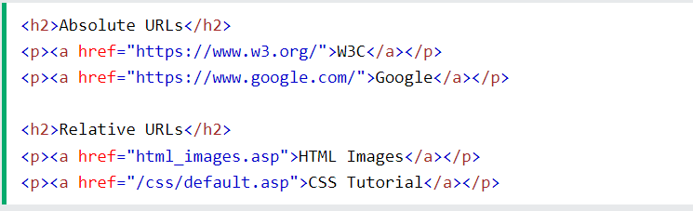

### Link to an Email Address

<a href="mailto:someone@example.com">Send email</a>

### Use an Image as a Link

<a href="default.asp">  
<img src="smiley.gif" alt="HTML tutorial" style="width:42px;height:42px;">  
</a>

### Button as a Link

<button onclick="document.location='default.asp'">HTML Tutorial</button>

### Link Colors

By default, a link will appear like this (in all browsers):

* An unvisited link is underlined and blue
* A visited link is underlined and purple
* An active link is underlined and red

You can change the link state colors, by using CSS such as :

a:link {  
a:visited {  
a:hover {  
a:active {

### Link Bookmark

* Use the id attribute (id="value") to define bookmarks in a page
* Use the href attribute (href="#value") to link to the bookmark

# HTML Images

### Def

Images can improve the design and the appearance of a web page.

The <img> tag is empty, it contains attributes only, and does not have a closing tag.

The <img> tag has two required attributes:

* src - Specifies the path to the image
* alt - Specifies an alternate text for the image

### Syntax

<img src="url" alt="alternatetext">

### Summary

* Use the HTML <img> element to define an image
* Use the HTML src attribute to define the URL of the image
* Use the HTML alt attribute to define an alternate text for an image
* Use the HTML width and height to define the size of the image
* Use the CSS float property to let the image float to the left or to the right

### Image Map

* The HTML <map> tag defines an image map.
* An image map is an image with clickable areas.
* The areas are defined with one or more <area> tags.

Attributes used in image Map

1. usemap 2.map 🡪 name 3.area 🡪 shape, coords

***Eg:***

<img src="workplace.jpg" alt="Workplace" usemap="#workmap">  
<map name="workmap">  
  <area shape="rect" coords="34,44,270,350" alt="Computer" href="computer.htm">  
  </map>

**Summary – Image Map**

* Use the HTML <map> element to define an image map
* Use the HTML <area> element to define the clickable areas in the image map
* Use the HTML usemap attribute of the <img> element to point to an image map

***Images in another folder***

src="/images/html5.gif"

***Images on Another Server/Website***

src="https://www.w3schools.com/images/w3school_green.jpg"

### Image Floating

Use the CSS float property to let the image float to the right or to the left of a text:

<p><img src="smiley.gif" alt="Smiley face" style="float:right;width:42px;height:42px;">  
The image will float to the right of the text.</p>

### Image as link

To use an image as a link, put the <img> tag inside the <a> tag:

### Background Image

use the HTML style attribute and the CSS background-image property.

It is either used in specific element or entire page

***Syntax:***

<p style="background-image: url('img_girl.jpg');">

1.background-repeat: no-repeat; 2. background-size: cover;

3. background-attachment: fixed; 4. background-size: 100% 100%;

### Picture Element

The HTML <picture> element gives web developers more flexibility in specifying image resources

<source media="(min-width: 650px)" srcset="img_food.jpg">

It is used for two main reasons such as:

* 1. Bandwidth 2. Format Support

### Fav Icons

A favicon is a small image displayed next to the page title in the browser tab.

***Syntax***

<link rel="icon" type="image/x-icon" href="/images/favicon.ico">

### Common Image Formats

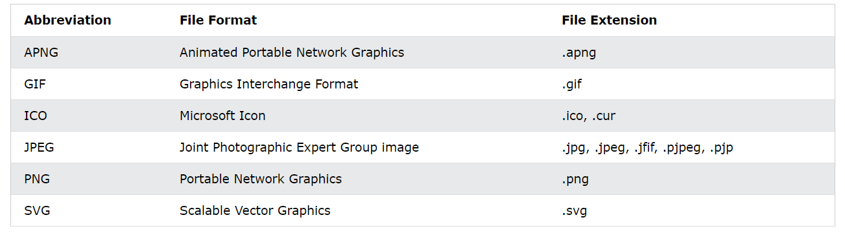

# HTML Tables

## Def

HTML tables allow web developers to arrange data into rows and columns.

Each table cell is defined by a <td> and a </td> tag.

## Syntax

<table> ….. </table>

## Html Table Tags

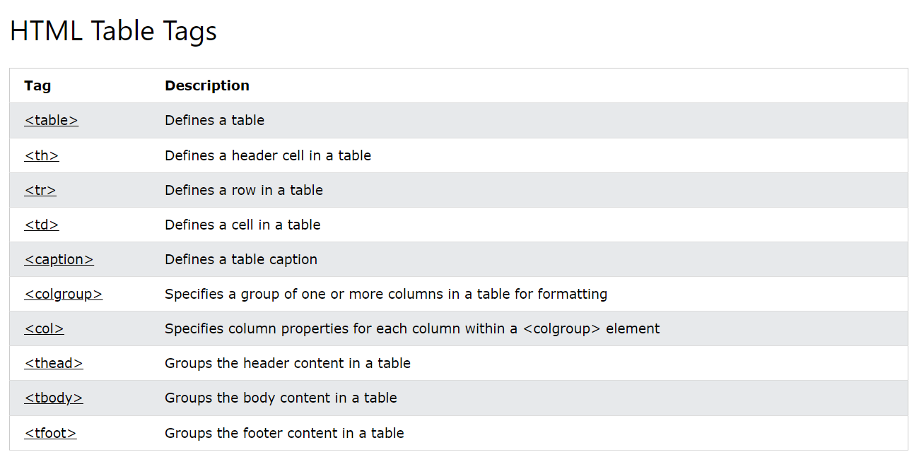

## Table Border

Use Border Property to specify the Size, Shape and Style.

Use Border-Collapse Property to specify the Single collapsed border

Use Border-radius property to specify the radius for round border

And border-style and border-color.

## *Table Size*

Use the style attribute with the width or height properties to specify the size of a table, row or column as like below:

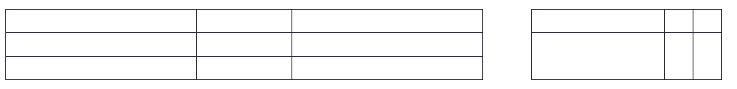

## Colgroup

The <colgroup> element should be used as a container for the column specifications.

If you want to style the two first columns of a table, use the <colgroup> and <col> elements.

<colgroup>  
    <col span="2" style="background-color: #D6EEEE">  
  </colgroup>

## Colspan & Rowspan

To make a cell span over multiple columns, use the colspan attribute.

To make a cell span over multiple rows, use the rowspan attribute.

## Table Strips

### Table - Vertical Zebra Stripes

td:nth-child(even), th:nth-child(even) {  
  background-color: #D6EEEE;  
}

### Table - Horizontal Zebra Stripes

tr:nth-child(even) {  
  background-color: #D6EEEE;  
}

### Combine Vertical and Horizontal Zebra Stripes

tr:nth-child(even) {  
  background-color: rgba(150, 212, 212, 0.4);  
}  
  
th:nth-child(even),td:nth-child(even) {  
  background-color: rgba(150, 212, 212, 0.4);  
}

# HTML Lists

## Def

HTML lists allow web developers to group a set of related items in lists.

There are three types of html list such as:

1. Unordered list
2. Ordered list
3. Description list

## 1. Unordered list

### Def

The HTML <ul> tag defines an unordered (bulleted) list.

Each list item starts with the <li> tag.

### Summary

Use the HTML <ul> element to define an unordered list

Use the CSS list-style-type property to define the list item marker

Use the HTML <li> element to define a list item

Lists can be nested

List items can contain other HTML elements

Use the CSS property float:left to display a list horizontally

### Eg

<ul>  
  <li>Coffee</li>  
  <li>Tea</li>  
  <li>Milk</li>  
</ul>

### List style type

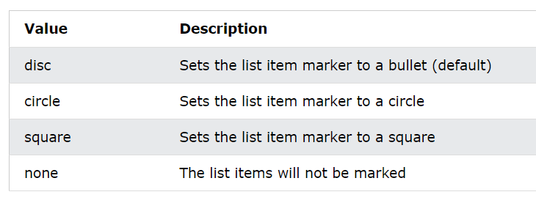

## 2. Ordered list

### Def

The HTML <ol> tag defines an ordered list. An ordered list can be numerical or alphabetical.

### Summary

Use the HTML <ol> element to define an ordered list

Use the HTML type attribute to define the numbering type

Use the HTML <li> element to define a list item

Lists can be nested

List items can contain other HTML elements

### Eg

<ol>  
  <li>Coffee</li>  
  <li>Tea</li>  
  <li>Milk</li>  
</ol>

### List style type

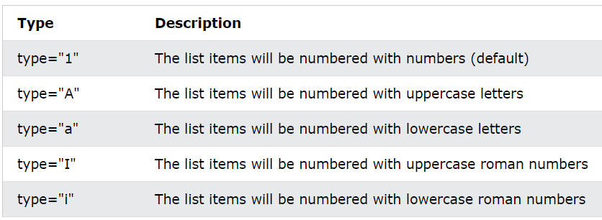

### Control list counting

By default, an ordered list will start counting from 1. If you want to start counting from a specified number, you can use the start attribute:

<ol start="50">

## 3. Description list

### Def

A description list is a list of terms, with a description of each term.

The <dl> tag defines the description list, the <dt> tag defines the term (name), and the <dd> tag describes each term:

### Summary

Use the HTML <dl> element to define a description list

Use the HTML <dt> element to define the description term

Use the HTML <dd> element to describe the term.

### Eg

<dl>  
  <dt>Coffee</dt>  
  <dd>- black hot drink</dd>  
  <dt>Milk</dt>  
  <dd>- white cold drink</dd>  
</dl>

# Block Element vs Inline Element

## Block Element

### Def

A block-level element always starts on a new line,

automatically add a margin before and after the element.

A block-level element always takes up the full width available

Two commonly used block elements are: <p> and <div>.

### The <div> Element

The <div> element is often used as a container for other HTML elements.

The <div> element has no required attributes, but style, class and id are common.

### Block level elements

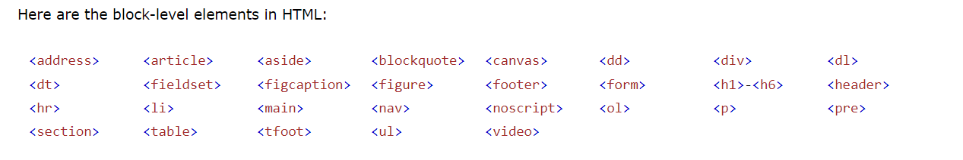

## Inline Elements

### Def

An inline element does not start on a new line.

An inline element only takes up as much width as necessary.

This is a <span> element inside a paragraph.

### The <span> Element

The <span> element is an inline container used to mark up a part of a text, or a part of a document.

The <span> element has no required attributes, but style, class and id are common.

### Inline Tags

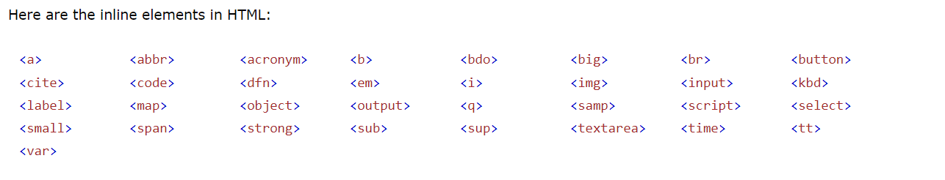

## Summary

A block-level element always starts on a new line and takes up the full width available

An inline element does not start on a new line and it only takes up as much width as necessary

# HTML Forms

## Def

An HTML form is used to collect user input. The user input is most often sent to a server for processing.

## Syntax

<form>  
 …. form elements ….  
</form>

## Form Attirubutes

1. ***Action Attribute***
2. ***Target Attribute***
3. ***Method Attribute***
4. ***Autocomplete Attribute***
5. ***Novalidate Attribute***

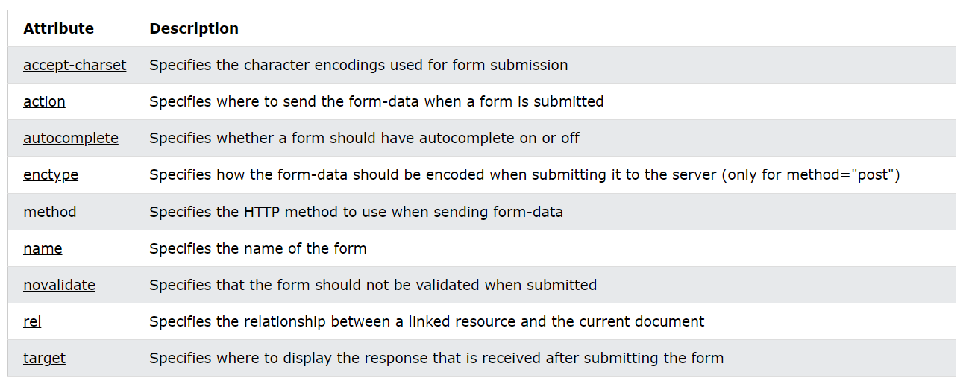

### Action Attribute

The action attribute defines the action to be performed when the form is submitted.

Usually, the form data is sent to a file on the server when the user clicks on the submit button.

<form action="/action_page.php">

### Target Attribute

The target attribute specifies where to display the response that is received after submitting the form.

<form action="/action_page.php" target="_blank">

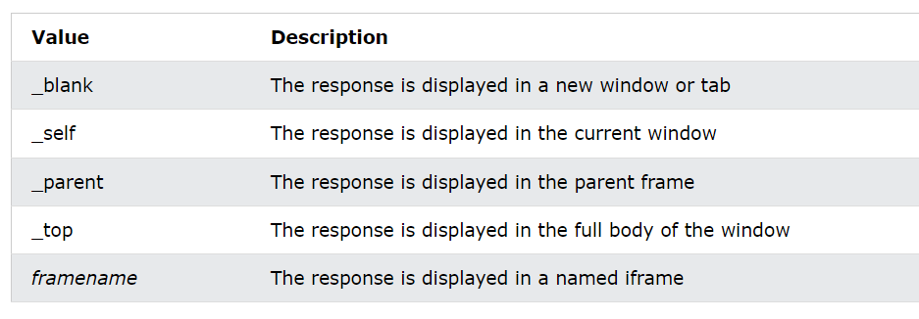

### Autocomplete Attribute

When autocomplete is on, the browser automatically complete values based on values that the user has entered before.

<form action="/action_page.php" autocomplete="on">

### Novalidate Attribute

The novalidate attribute is a boolean attribute, and  it specifies that the form-data (input) should not be validated when submitted.

<form action="/action_page.php" novalidate>

### 5. Method Attribute

The form-data can be sent as URL variables (with method="get") or as HTTP post transaction (with method="post").

<form action="/action_page.php" method="get">

#### **Notes on Get**

Appends the form data to the URL, in name/value pairs

NEVER use GET to send sensitive data! (the submitted form data is visible in the URL!)

The length of a URL is limited (2048 characters)

Useful for form submissions where a user wants to bookmark the result

GET is good for non-secure data, like query strings in Google

#### **Notes on Post**

Appends the form data inside the body of the HTTP request (the submitted form data is not shown in the URL)

POST has no size limitations, and be used to send large amounts of data.

Form submissions with POST cannot be bookmarked

## HTML Form Elements

The HTML <form> element can contain one or more of the following form elements:

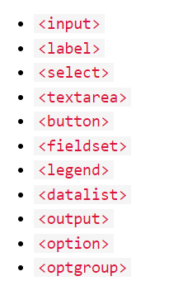

### Input Element

One of the most used form elements is the <input> element.

The <input> element can be displayed in several ways, depending on the type attribute.

<input type="text" id="fname" name="fname">

### Label Element

The <label> element defines a label for several form elements.

The <label> element is useful for screen-reader users

<label for="fname">First name:</label>

### Select Element

The <select> element defines a drop-down list.

The <option> element defines an option that can be selected.

Use the size attribute to specify the number of visible values.

Use the multiple attribute to select more than one value.

To define a pre-selected option, add the selected attribute to the option.

<select id="cars" name="cars">  
  <option value="volvo">Volvo</option>  
  <option value="saab">Saab</option>  
</select>

### Textarea Element

The <textarea> element defines a multi-line input field (a text area):

<textarea name="message" rows="10" cols="30"> Or

<textarea name="message" style="width:200px; height:600px;">

### Button Element

The <button> element defines a clickable button:

<button type="button" onclick="alert('Hello World!')">Click Me!</button>

### Fieldset and legend Elements

The <fieldset> element is used to group related data in a form.

The <legend> element defines a caption for the <fieldset> element.

### Datalist Element

The <datalist> element specifies a list of pre-defined options for an <input> element.

This is same as Drop-down list

### Output Element

The <output> element represents the result of a calculation (like one performed by a script).

  <output name="x" for="a b"></output>

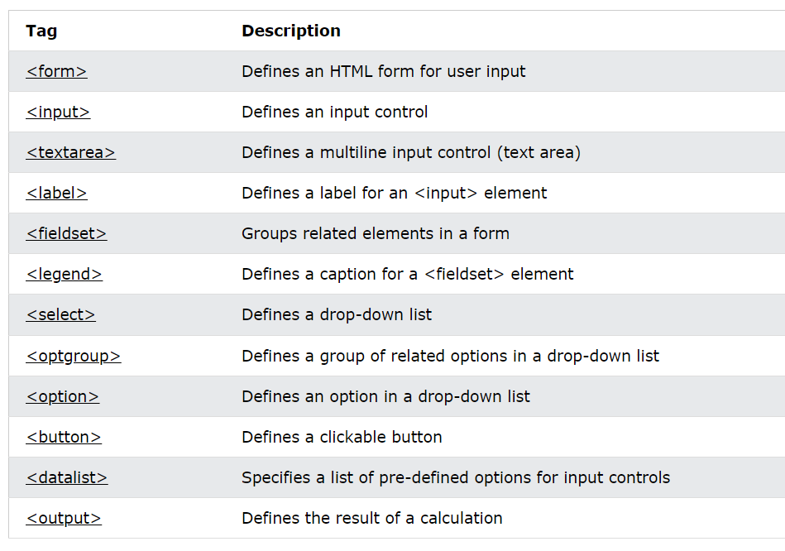

## Input Types

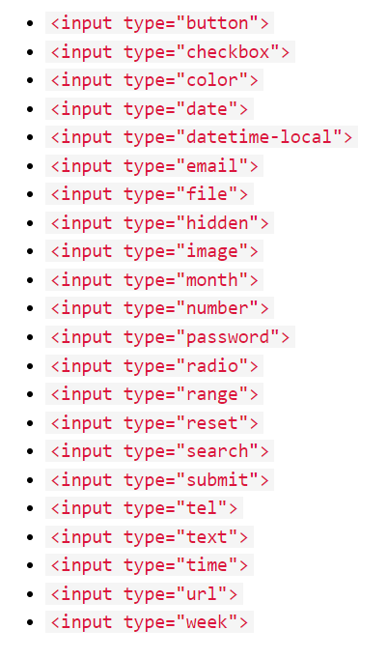

|  |  |
| --- | --- |
|  |  |

### 1. Input Type Text

  <input type="text" id="lname" name="lname">

### 2. Input Type Password

  <input type="password" id="pwd" name="pwd">

### 3. Input Type Radio

<input type="radio" id="javascript" name="fav_language"  value="JavaScript">  
   <label for="javascript">JavaScript</label>

### 4. Input Type Checkbox

<input type="checkbox" id="vehicle1" name="vehicle1"  value="Bike">  
   <label for="vehicle1"> I have a bike</label>

### 5. Input Type Button

<input type="button" onclick="alert('Hello World!')" value="Click Me!">

### 6. Input Type Submit

  <input type="submit" value="Submit">

### 7. Input Type Reset

  <input type="reset" value="Reset">

### 8. Input Type Email

  <input type="email" id="email" name="email">

### 9. Input Type Range

  <input type="range" id="vol" name="vol" min="0"  max="50">

### 10. Input Type File

  <input type="file" id="myfile" name="myfile">

### 11. Input Type Number

  <input type="number" id="quantity" name="quantity" min="1" max="5">

### 12. Input Type Tel

  <input type="tel" id="phone" name="phone" pattern= "[0-9]{3}-[0-9]{2}-[0-9]{3}">

### 13. Input Type Url

  <input type="url" id="homepage" name="homepage">

### 14. Input Type Hidden

  <input type="hidden" id="custId" name="custId"  value="3487">

### 15. Input Type Image

<input type="image" src="img_submit.gif" alt="Submit" width="48" height="48">

### 16. Input Type Color

  <input type="color" id="favcolor" name="favcolor">

### 17. Input Type Datetime-local

  <input type="datetime-local"  id="birthdaytime" name="birthdaytime">

### 18. Input Type Date

  <input type="date" id="datemin" name="datemin"  min="2000-01-02">

### 19. Input Type Time

  <input type="time" id="appt" name="appt">

### 20. Input Type Month

  <input type="month" id="bdaymonth" name="bdaymonth">

### 21. Input Type Week

  <input type="week" id="week" name="week">

### 22. Input Type Search

  <input type="search" id="gsearch" name="gsearch">

## Input Attributes

This chapter describes the different attributes for the HTML <input> element:

1. value Attribute 2. readonly Attribute

3. disabled Attribute 4. size Attribute

5. maxlength Attribute 6. min and max Attributes

7. multiple Attribute 8. pattern Attribute

9. placeholder Attribute 10. required Attribute

11. step Attribute 12. autofocus Attribute

13. height and width Attribute 14. list Attribute

15. autocomplete Attribute

### 1. value Attribute

The input value attribute specifies an initial value for an input field.

### 2. readonly Attribute

The input readonly attribute specifies that an input field is read-only.

A read-only input field cannot be modified.

### 3. disabled Attribute

A disabled input field is unusable and un-clickable.

The value will not be sent when submitting the form.

### 4. size Attribute

The input size attribute specifies the visible width, in characters, of an input field.

Works with: text, search, tel, url, email, and password.

### 5. maxlength Attribute

The input maxlength attribute specifies the maximum number of characters allowed in an input field.

### 6. min and max Attributes

The input min and max attributes specify the minimum and maximum values for an input field.

works with: number, range, date, datetime-local, month, time and week.

### 7. multiple Attribute

The input multiple attribute specifies that the user is allowed to enter more than one value in an input field.

Works with: email, and file.

### 8. pattern Attribute

The input pattern attribute specifies a regular expression

Works with: text, date, search, url, tel, email, and password.

### 9. placeholder Attribute

The short hint is displayed in the input field before the user enters a value.

Works with: text, search, url, tel, email, and password.

### 10. required Attribute

The input required attribute specifies that an input field must be filled.

Works with: text, search, url, tel, email, password, date pickers, number, checkbox, radio, and file.

### 11. step Attribute

The input step attribute specifies the intervals for an input field.

Works with: number, range, date, datetime-local, month, time and week.

### 12. autofocus Attribute

automatically get focus when the page loads.

### 13. height and width Attributes

specify the height and width of an <input type="image"> element.

### 14. list Attribute

The input list attribute refers to a <datalist> element that contains pre-defined options for an <input> element.

### 15. autocomplete Attribute

Allows the browser to predict the value.

Works with: text, search, url, tel, email, password, datepickers, range, and color.

## Input form* Attributes

This chapter describes the different form* attributes for the HTML <input> element.

This attribute overrides the target attribute of the <form> element.

Mostly these are used with: submit and image.

Some of the attributes are :

1. form Attribute

2. formaction Attribute

3. formenctype Attribute

4. formmethod Attribute

5. formtarget Attribute

6. formnovalidate Attribute

# HTML Media

## What is Multimedia?

Multimedia on the web is sound, music, videos, movies, and animations.

Web pages often contain multimedia elements of different types and formats.

## Common video formats

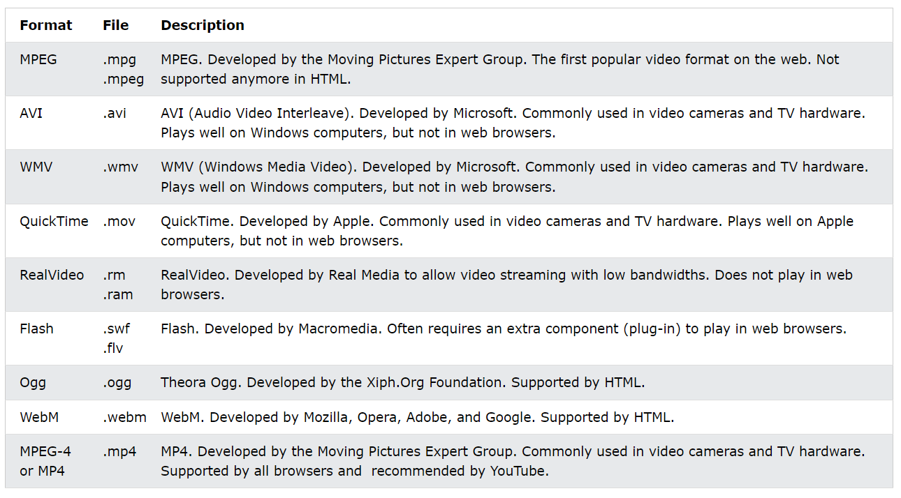

## Common audio formats

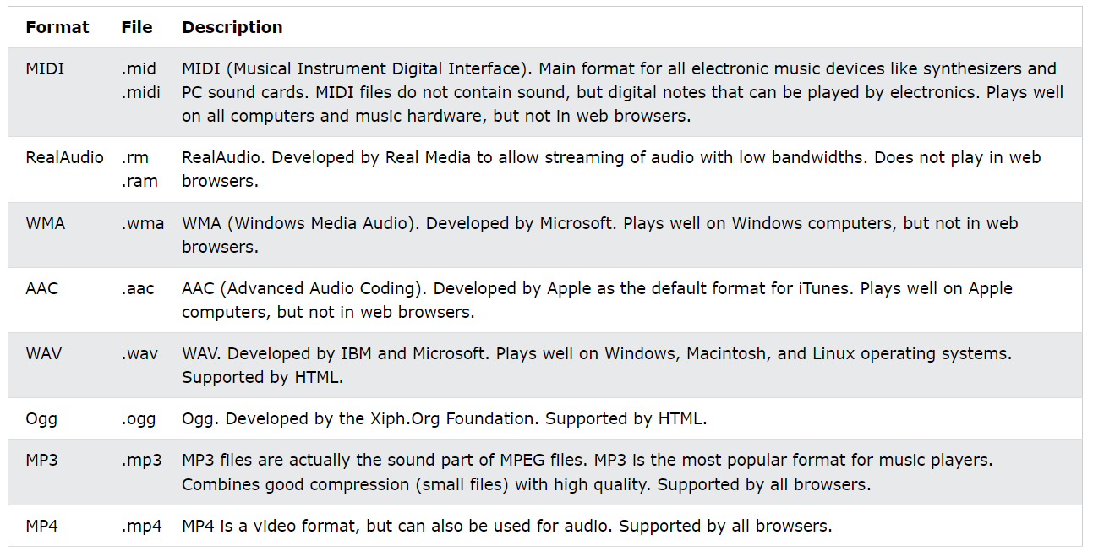

## How it Works

The controls attribute adds video controls, like play, pause, and volume.

It is a good idea to always include width and height attributes.

The <source> element allows you to specify alternative video files which the browser may choose from.

The text will only be displayed in browsers that do not support the <video> element.

To start a video automatically, use the autoplay attribute:

Add muted after autoplay to start playing automatically (but muted).

## HTML Audio/ Video - Methods, Properties, and Events

The HTML DOM defines methods, properties, and events for the <audio> element.

This allows you to load, play, and pause audios, as well as set duration and volume.

There are also DOM events that can notify you when an audio begins to play, is paused, etc.

## HTML Plug-ins

Plug-ins are computer programs that extend the standard functionality of the browser.

Plug-ins were designed to be used for many different purposes:

* To run Java applets
* To run Microsoft ActiveX controls
* To display Flash movies
* To display maps
* To scan for viruses
* To verify a bank id

Most browsers no longer support Java Applets and Plug-ins.

### Object element

The <object> element defines an embedded object within an HTML document.

It was designed to embed plug-ins (like Java applets, PDF readers, and Flash Players) in web pages, but can also be used to include HTML in HTML.

<object width="100%" height="500px" data="snippet.html"></object>

### Embed element

Web browsers have supported the <embed> element for a long time. However, it has not been a part of the HTML specification before HTML5.

<embed width="100%" height="500px" src="snippet.html">

## HTML Video

### Def

The HTML <video> element is used to show a video on a web page.

### Example

<video width="320" height="240" controls>  
  <source src="movie.mp4" type="video/mp4">  
  <source src="movie.ogg" type="video/ogg">  
Your browser does not support the video tag.  
</video>

### Tags used

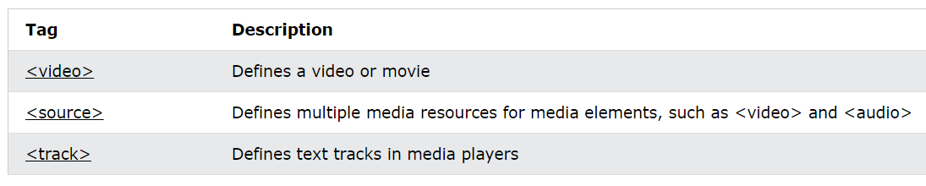

## HTML Audio

### Def

The HTML <audio> element is used to play an audio file on a web page.

### Example

<audio controls autoplay>  
  <source src="horse.ogg" type="audio/ogg">  
  <source src="horse.mp3" type="audio/mpeg">  
Your browser does not support the audio element.  
</audio>

## HTML Iframes Element

### Def

An inline frame is used to embed another document within the current HTML document.

An HTML iframe is used to display a web page within a web page.

### Syntax

<iframe src="url" title="description"></iframe>

### Summary

* The HTML <iframe> tag specifies an inline frame
* The src attribute defines the URL of the page to embed
* Always include a title attribute (for screen readers)
* The height and width attributes specify the size of the iframe
* Use border:none; to remove the border around the iframe
* The target attribute of the link must refer to the name attribute of the iframe: